Executive Summary
The Workspace feature allows users to create workspaces, so that users can group projects and share them with specific teams. This feature will enable users to seamlessly switch between different workspaces, ensuring that they can easily access and manage the relevant projects based on their current context or team collaboration needs. It also allows them to manage their sources under distinct workspaces, including personal.

Target Release | 18/10/2024
Epic | Workspaces
Document Status | {READY}
Owner | Oscar Souchaud

Concept Doc | https://docs.google.com/document/d/16kBnuCiv_9cEuJfQxCje_FEMxg_D-7YwelXqjqnowTQ/edit
Related Doc | https://docs.google.com/document/d/1mTl6t1wJWojqY8ChZaKZs5utuNxdyyfTVGF86TR2S4Q/edit
Figma Link | https://www.figma.com/design/n2FYTev0A6bT7CCK3626BR/Haibrid-DS-v1.2?node-id=9490-11462&t=FiIaBZz0x3PpuU6o-4

Objective
Strategically, the workspaces allows potential users to share specific projects to their own users who may be different companies, or teams.

Assumptions
- Users may want to be able to switch between workspaces in the browser extension and the snackbar windows
- The list of the projects should be updated based on the selected workspace

Success metrics
List project goals and the metrics you'll use to judge its success

Goal | Metric
Workspace switching interaction | User feedback on the ease of navigation and workspace switching.  .

Requirements

Menu Icon and General Layout
- Sliding Menu Trigger: Clicking the “Menu” icon will open a sliding menu, which will cover ¾ of the extension window as an overlay from the right-hand side.
- Sliding Menu Closure: The same Menu icon should appear in the upper right corner of the sliding menu, allowing users to close the menu by clicking on it again.

Sliding Menu Content
- There should also be the user’s avatar located in the left corner of the menu, and there should be an option to log out.
- Title: A clear title should be displayed at the top of the menu to indicate the menu's purpose.
- Workspace List: All available workspaces must be listed in the sliding menu.
  - Checkmark for Selected Workspace: The chosen/active workspace should be highlighted with a checkmark on the right side of the workspace name.
  - Switching Workspaces: Clicking on any workspace name should automatically select that workspace and close the sliding menu.

Menu Interaction
- Clicking the Menu Icon: Clicking on the “Menu” icon should initiate a smooth slide animation that brings the menu into view.
- Closing the Sliding Menu: Clicking on the “Menu” icon again while the menu is open will trigger the sliding animation in reverse, closing the menu.
- Automatic Menu Closure: When the user selects a new workspace, the menu should automatically close after the selection.

Workspace Switching
- Workspace Selection: The user should be able to switch between multiple workspaces.
- Visual Feedback: Once a workspace is selected, the chosen workspace should be marked with a checkmark on the right side.
- Auto Save Workspace: After switching, the newly selected workspace should become the active workspace for subsequent sessions, unless the user switches it again.

User Avatar
- Avatar Display: The user’s avatar should always be visible in the upper right corner of the sliding menu.
- Hidden Settings & Log Out Options: Additional options like “Settings” and “Log Out” should remain hidden within the avatar interaction (could be revealed on hover or click if needed).

User interaction and design
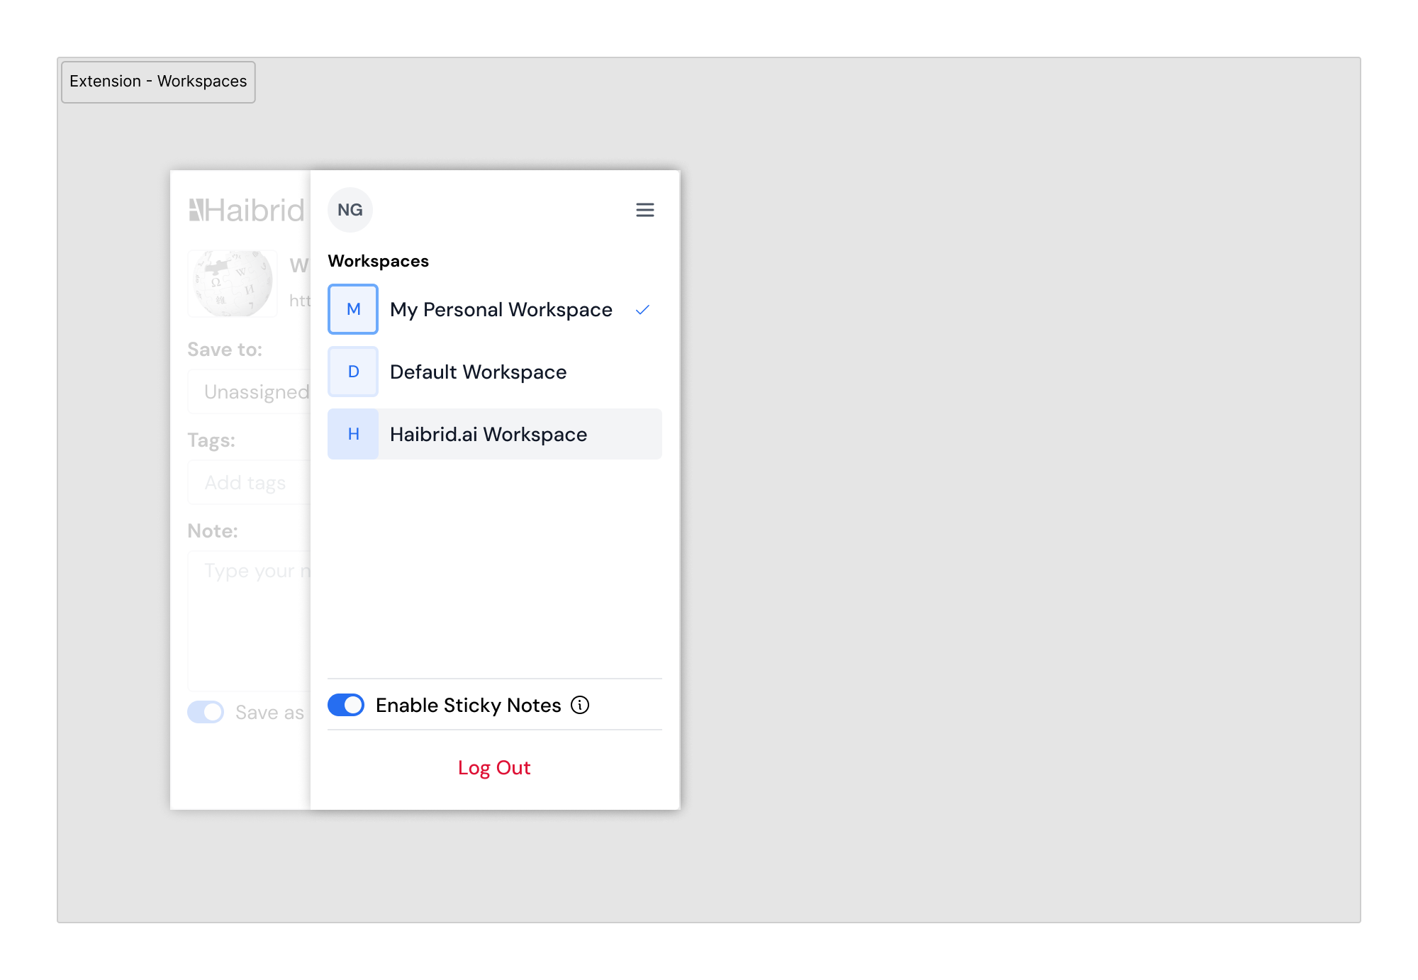

Open Questions
List all open questions for future discussion, reference or tracking

Out of Scope
List the features discussed which are out of scope or might be revisited in a later release.

